WEEK 8 – RARE EVENT MODELLING

PYTHON SCRIPT

from imblearn.under_sampling import RandomUnderSampler  
import pandas as pd  
import numpy as np  
from Class_replace_impute_encode import ReplaceImputeEncode  
from Class_tree import DecisionTree  
from sklearn import tree  
  
  
# Event is good credit = 1 o.e false positive will have greatest loss.  
  
def loss_cal(y, y_predict, fp_cost, fn_cost, display=True):  
 loss = [0, 0] #False Neg Cost, False Pos Cost  
 conf_mat = [0, 0, 0, 0] #tn, fp, fn, tp  
 for j in range(len(y)):  
 if y[j]==0:  
 if y_predict[j]==0:  
 conf_mat[0] += 1 #True Negative  
 else:  
 conf_mat[1] += 1 #False Positive  
 loss[1] += fp_cost[j]  
 else:  
 if y_predict[j]==1:  
 conf_mat[3] += 1 #True Positive  
 else:  
 conf_mat[2] += 1 #False Negative  
 loss[0] += fn_cost[j]  
 if display:  
 fn_loss = loss[0]  
 fp_loss = loss[1]  
 total_loss = fn_loss + fp_loss  
 misc = conf_mat[1] + conf_mat[2]  
 misc = misc/len(y)  
 print("{:.<23s}{:10.4f}".format("Misclassification Rate", misc))  
 print("{:.<23s}{:10.0f}".format("False Negative Cost", fn_loss))  
 print("{:.<23s}{:10.0f}".format("False Positive Cost", fp_loss))  
 print("{:.<23s}{:10.0f}".format("Total Loss", total_loss))  
 return loss, conf_mat  
  
  
attribute_map = {  
 'age':[0,(1, 120),[0,0]],  
 'amount':[0,(0, 20000),[0,0]],  
 'duration':[0,(1,100),[0,0]],  
 'checking':[2,(1, 2, 3, 4),[0,0]],  
 'coapp':[2,(1,2,3),[0,0]],  
 'depends':[1,(1,2),[0,0]],  
 'employed':[2,(1,2,3,4,5),[0,0]],  
 'existcr':[2,(1,2,3,4),[0,0]],  
 'foreign':[1,(1,2),[0,0]],  
 'good_bad':[1,('bad', 'good'),[0,0]],  
 'history':[2,(0,1,2,3,4),[0,0]],  
 'housing':[2,(1, 2, 3), [0,0]],  
 'installp':[2,(1,2,3,4),[0,0]],  
 'job':[2,(1,2,3,4),[0,0]],  
 'marital':[2,(1,2,3,4),[0,0]],  
 'other':[2,(1,2,3),[0,0]],  
 'property':[2,(1,2,3,4),[0,0]],  
 'resident':[2,(1,2,3,4),[0,0]],  
 'savings':[2,(1,2,3,4,5),[0,0]],  
 'telephon':[1,(1,2),[0,0]] }  
  
df = pd.read_excel("CRED.xlsx")  
# Encode for Logistic Regression, drop last one-hot column  
rie = ReplaceImputeEncode(data_map=attribute_map, nominal_encoding='one-hot', \  
 interval_scale = 'std', drop=False, display=False)  
encoded_df = rie.fit_transform(df)  
# Create X and y, numpy arrays  
# bad=0 and good=1  
y = np.asarray(encoded_df['good_bad']) # The target is not scaled or imputed  
X = np.asarray(encoded_df.drop('good_bad',axis=1))  
  
# Setup false positive and false negative costs for each transaction  
fp_cost = np.array(df['amount'])  
fn_cost = np.array(0.15*df['amount'])  
  
treeclassifier = tree.DecisionTreeClassifier(criterion='gini', max_depth=8, min_samples_split=5, min_samples_leaf=5)  
treeclassifier = treeclassifier.fit(X, y)  
  
print("\nDecision Tree Model using Entire Dataset")  
col = rie.col  
col.remove('good_bad')  
DecisionTree.display_binary_metrics(treeclassifier, X, y)  
print("\nLoss Calculations from a Decision Tree")  
print("Model fitted to the entire dataset:")  
loss, conf_mat = loss_cal(y, treeclassifier.predict(X), fp_cost, fn_cost)  
  
# Setup random number seeds  
rand_val = np.array([1, 12, 123, 1234, 12345, 654321, 54321, 4321, 321, 21])  
# Ratios of Majority:Minority Events  
ratio = [ '50:50', '60:40', '70:30', '75:25', '80:20', '85:15' ]  
# Dictionaries contains number of minority and majority events in each ratio sample  
# n_majority = ratio x n_minority  
rus_ratio = ({0:500, 1:500}, {0:500, 1:750}, {0:500, 1:1166}, {0:500, 1:1500}, {0:500, 1:2000}, {0:500, 1:2833})  
  
# Best model is one that minimizes the loss  
min_loss = 9e+15  
best_ratio = 0  
for k in range(len(rus_ratio)):  
 rand_vals = (k+1)*rand_val  
 print("\nDecision Tree Model using " + ratio[k] + " RUS")  
 fn_loss = np.zeros(len(rand_vals))  
 fp_loss = np.zeros(len(rand_vals))  
 misc = np.zeros(len(rand_vals))  
 for i in range(len(rand_vals)):  
 rus = RandomUnderSampler(ratio=rus_ratio[k], \  
 random_state=rand_vals[i], return_indices=False, \  
 replacement=False)  
 X_rus, y_rus = rus.fit_sample(X, y)  
 dtree = tree.DecisionTreeClassifier(criterion='gini', max_depth=8, \  
 min_samples_split=5, min_samples_leaf=5)   
 dtree.fit(X_rus, y_rus)  
 loss, conf_mat = loss_cal(y, dtree.predict(X), fp_cost, fn_cost,\  
 display=False)  
 fn_loss[i] = loss[0]  
 fp_loss[i] = loss[1]  
 misc[i] = conf_mat[1] + conf_mat[2]  
 misc = np.sum(misc)/(10500 * len(rand_vals))  
 fn_avg_loss = np.average(fn_loss)  
 fp_avg_loss = np.average(fp_loss)  
 total_loss = fn_loss + fp_loss  
 avg_loss = np.average(total_loss)  
 std_loss = np.std(total_loss)  
 print("{:.<23s}{:10.4f}".format("Misclassification Rate", misc))  
 print("{:.<23s}{:10.0f}".format("False Negative Cost", fn_avg_loss))  
 print("{:.<23s}{:10.0f}".format("False Positive Cost", fp_avg_loss))  
 print("{:.<23s}{:10.0f}{:5s}{:<10.2f}".format("Total Loss", avg_loss, \  
 " +/- ", std_loss))  
 if avg_loss < min_loss:  
 min_loss = avg_loss  
 best_ratio = k  
  
  
# Ensemble Modeling - Averaging Classification Probabilities  
avg_prob = np.zeros((len(y),2))  
# Setup 100 random number seeds for use in creating random samples  
np.random.seed(12345)  
max_seed = 150000  
rand_value = np.random.randint(1, high=max_seed, size=10)  
# Model 100 random samples, each with a 70:30 ratio  
for i in range(len(rand_value)):  
 rus = RandomUnderSampler(ratio=rus_ratio[best_ratio], \  
 random_state=rand_value[i], return_indices=False, \  
 replacement=False)  
 X_rus, y_rus = rus.fit_sample(X, y)  
 dtree = tree.DecisionTreeClassifier(criterion='gini', max_depth=8, \  
 min_samples_split=5, min_samples_leaf=5)  
 dtree.fit(X_rus, y_rus)  
 avg_prob += dtree.predict_proba(X)  
avg_prob = avg_prob/len(rand_value)  
# Set y_pred equal to the predicted classification  
y_pred = avg_prob[0:,0] < 0.5  
y_pred.astype(np.int)  
# Calculate loss from using the ensemble predictions  
print("\nEnsemble Estimates based on averaging",len(rand_value), "Models")  
loss, conf_mat = loss_cal(y, y_pred,fp_cost,fn_cost)

SCREENSHOT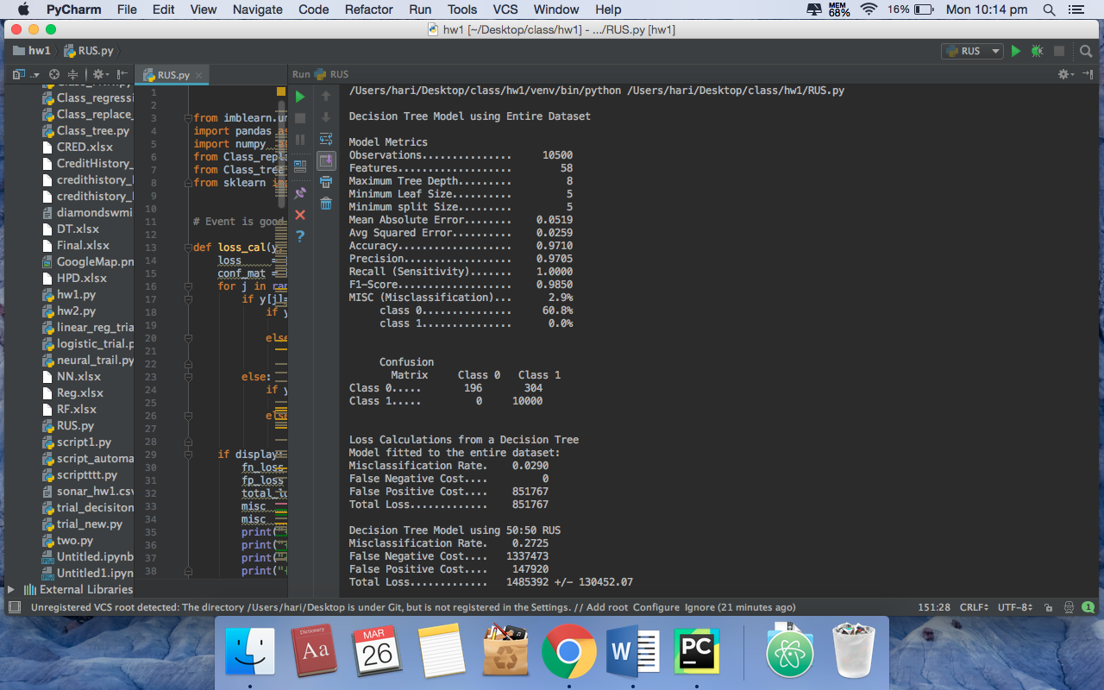

OUTPUT:

Decision Tree Model using Entire Dataset

Model Metrics

Observations............... 10500

Features................... 58

Maximum Tree Depth......... 8

Minimum Leaf Size.......... 5

Minimum split Size......... 5

Mean Absolute Error........ 0.0519

Avg Squared Error.......... 0.0259

Accuracy................... 0.9710

Precision.................. 0.9705

Recall (Sensitivity)....... 1.0000

F1-Score................... 0.9850

MISC (Misclassification)... 2.9%

class 0............... 60.8%

class 1............... 0.0%

Confusion

Matrix Class 0 Class 1

Class 0..... 196 304

Class 1..... 0 10000

Loss Calculations from a Decision Tree

Model fitted to the entire dataset:

Misclassification Rate. 0.0290

False Negative Cost.... 0

False Positive Cost.... 851767

Total Loss............. 851767

Decision Tree Model using 50:50 RUS

Misclassification Rate. 0.2725

False Negative Cost.... 1337473

False Positive Cost.... 147920

Total Loss............. 1485392 +/- 130452.07

Decision Tree Model using 60:40 RUS

Misclassification Rate. 0.1962

False Negative Cost.... 949554

False Positive Cost.... 258551

Total Loss............. 1208105 +/- 132413.99

Decision Tree Model using 70:30 RUS

Misclassification Rate. 0.1021

False Negative Cost.... 468444

False Positive Cost.... 423333

Total Loss............. 891777 +/- 69286.81

Decision Tree Model using 75:25 RUS

Misclassification Rate. 0.0742

False Negative Cost.... 333280

False Positive Cost.... 515937

Total Loss............. 849217 +/- 75304.62

Decision Tree Model using 80:20 RUS

Misclassification Rate. 0.0566

False Negative Cost.... 227334

False Positive Cost.... 583129

Total Loss............. 810463 +/- 90470.82

Decision Tree Model using 85:15 RUS

Misclassification Rate. 0.0396

False Negative Cost.... 120918

False Positive Cost.... 650800

Total Loss............. 771718 +/- 75140.48

Ensemble Estimates based on averaging 10 Models

Misclassification Rate. 0.0246

False Negative Cost.... 0

False Positive Cost.... 595382

Total Loss............. 595382

Process finished with exit code 0